 | CLEARANCE CERTIFICATE |  |  |  |  |  | 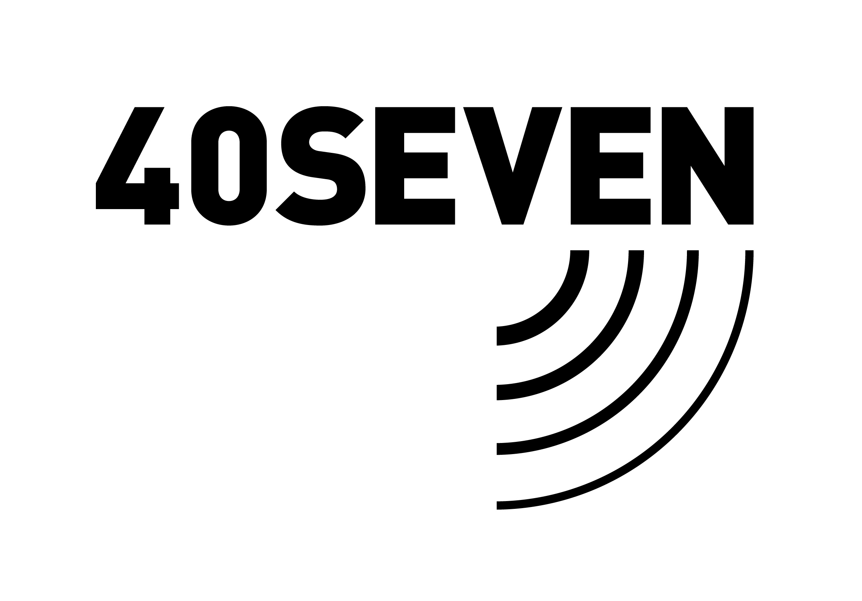
Project Name: | LEEDS SIDINGS | Description of Work | CLEARENCE |  | Date: | 16-12-2020
Project No: | 2139 | Name of Surveyor | L BURGESS |  | No of staff on site | ONE
Client | THE SCREW CENTER | Is the Risk of Strike  (tick box) |  | HIGH RISK, IF YES please specify actions taken
 |  | Is the Risk of Strike  (tick box) |  | MEDIUM RISK, IF YES please specify actions taken
 |  | Is the Risk of Strike  (tick box) | LOW | LOW RISK, IF YES please specify actions taken

STEPS | HAZARDS | RISK  HIGH / MED / LOW | HOW RO REDUCE OR ELIMINATE THE RISK | REMAINING RISK
UFC 1 | NONE | LOW
PCB 1/2 | NONE | LOW
DMU R1/5 | NONE | LOW
TSS 1/2RE | NONE | LOW
TSS 1/2 RW | NONE | LOW
A NEW CLEARANCE CERTIFICATE IS REQUIRED EACH DAY – UPDATED IF ADDITONAL HAZARDS OR CIRCUMDTANCES CHANGE AND SAFE DIGGING PRACTISES MUST ALWAYS BE PERFORMED

BEFORE WORK COMMENCES | CHECKLIST
As the contractor I confirm that I have carried out the works as agreed and discussed the hazards if any  Signed: Date:16-12-2020 | Clearance certificate fully completed YES / NO  All obvious hazards identified and precautions taken YES / NO  Certificate signed by client / representative whilst on site YES / NO  Did a near miss occur whilst on site YES / NO  IF CERTIFICATE IS NOT SIGNED OFF BY CLIENT WHISLT ON SITE, THEN IT WILL NEED TO BE EMAILED AND RETURNED SIGNED BY CLIENT
On behalf of the site, I have reviewed and agreed with the work arrangements

Signed: Date:16-12-2020

